INSOMNIAC StoreTracker™ Guide

Required Information for Setup
Welcome to INSOMNIAC® StoreTracker! For a smooth onboarding experience, we have outlined the key information we need from you and your team. Please complete these items to provide the necessary details to get started!

🏢 Company, Contact Information, & Facility Information
Please fill out the following details to help us get your StoreTracker setup started:
- Company Name:
- Primary Contact Name:
- Email Address:
- Phone Number:
- Preferred Start Date for Onboarding:
- Number of Facilities:
- Facility Names or IDs (if available):
- Property Management System (PMS) Used:
- API ID (if applicable):
- Unit List (Please Provide)

Task List & Workflow Preferences
StoreTracker can be customized for your task lists or workflows. Just attach or describe them.
- Include preferred Task Categories or labels (e.g., Maintenance, Leasing, Unit Repair, Morning Workday, etc.)
- Any repeating tasks or schedules we should set up?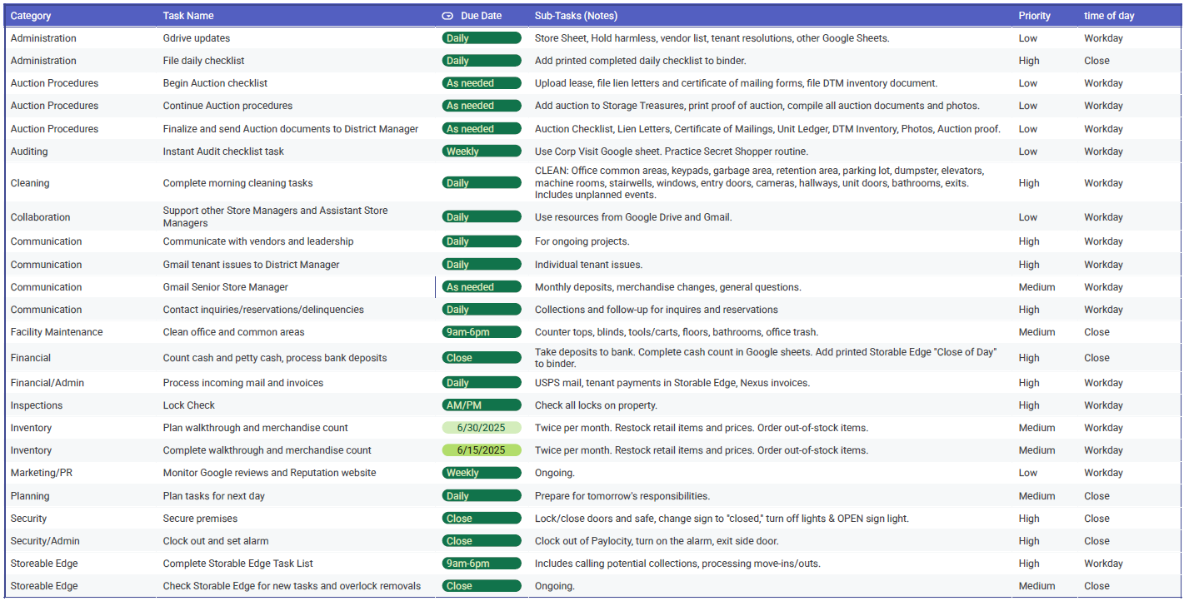

Facility Assets & Local Requirements
StoreTracker helps you manage and monitor facility assets—like HVAC units, fire extinguishers, and security systems—along with any location-specific requirements.
- Some facilities may have unique needs based on local regulations, weather conditions, or company policies. For example, a city might require regular inspections of fire extinguishers or storm-related equipment.
To help us set up your account accurately, please share any known asset-related requirements or recurring tasks specific to your facility:
- Do any of your facilities have local compliance requirements?
Examples: fire extinguisher inspections, snow removal equipment checks, pest control schedules, HVAC Coil Replacement, etc.
☐ Yes (please describe below)
☐ No
- Do you track any unique assets at your facility?
Examples: solar panels, backup generators, irrigation systems
☐ Yes (please list below)
☐ No
- Would you like us to create recurring tasks or reminders for these items?
☐ Yes (please describe below)
☐ No

User Roles & Access
- For each team member to be added, please provide:
  - Name:
  - Role:
  - Email:
  - Contact Information:
  - Will receive email notifications (yes/no):
  - Assigned access level (refer to table below):

🔐 Standard Permission Templates by Role
Permission Group Name | Admin | Add | Edit | Delete
🔧 Admin (Full Access) | ✅ | ✅ | ✅ | ✅
📋 Manager | ⬜ | ✅ | ✅ | ✅
👷 Site Operator | ⬜ | ✅ | ✅ | ⬜
🔍 Viewer (Read-Only) | ⬜ | ⬜ | ⬜ | ⬜

Note: Custom names may be added to Permission Group Name

Onboarding & Testing Preference
- Any Specific use cases or scenarios you would like us to cover?
- Are there any internal stakeholders who should be included in the onboarding/testing phase?

Additional Notes or Requests
Any other information or documentation you would like to share with us?

